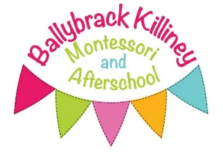

**Observation and Assessment**

At Ballybrack Killiney Montessori & Afterschool Ltd, the children are continually monitored from when they begin in the class until they leave us. We complete a settling in observation on each child to set a base line. Parents also fill in a “getting to know you” form which gives the keyworker a picture of the child’s likes/dislikes, favourite book, family members, etc.



We operate a keyworker system: Teachers in each class have key children. The role of the keyworker is to liaise with parents, complete observations, developmental assessments, leaving journals and present new materials weekly.

Each child has a keyworker in their class that completes a focus week for their individual key children each term. Three observation weeks are completed each year, accompanied with photos, to ensure that each child is meeting his/her goals. We also send a parents focus sheet home for parents to complete and ask that photos from home are also sent in. These are all added to the child’s learning journal. At the end of the child’s focus week the keyworker shares information with the parents.

Observations involve watching and listening to the children and seeing how the children react to the activities and resources. This allows the staff to plan an emergent curriculum based on the children’s interests. Group observations are filled in on a focus sheet for the week which is linked to Aistear.

Every child leaving the service receives a written report or “Mo Sceal” which contains our notes and observations, along with our recommendations for the future. This is sent home for parents to comment on and is then sent on to the child’s primary school.

We have a special report form, which we use if necessary. If the child is being assessed by another agency (e.g. psychologist, speech therapist) we will provide a written report or fill in an assessment form provided by the agency if requested to.

All observations and reports and treated with confidentiality.