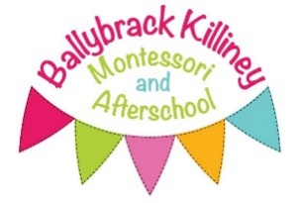

PET POLICY

At Ballybrack Killiney Montessori & Afterschool Ltd we recognise that the provision of pets within the setting provides children with a wealth of learning opportunities regarding what animals need to live and thrive and the importance of taking care of them correctly.

The service has multiple pets, Sandy the goldfish lives on Eve’s desk in a tank, Beans & Toast the rabbits live outside in their enclosure and Sam the dog lives with Sofia and she comes to visit once a week. Beans and Toast go home to Sophie’s house each weekend and when the service is closed, or it is extremely hot or cold.

Staff are fully aware of the importance of health and hygiene when children are in contact with animals. Staff guide the children not to put their hands near their faces when they have been in contact with the pets or pet food or bedding. They must wash their hands after touching any of these. Staff must also wash their hands thoroughly after having contact with any of these.

Children will often help staff to clean out the pets’ living quarters and when doing so they must wear disposable gloves and apron and wash their hands thoroughly afterwards. Staff are assigned duties to care for the pets regularly such as cleaning, feeding, etc.

A risk assessment is carried out before any pet is introduced to the service to ensure that all necessary precautions have been taken to avoid accidents, injury, or the spread of infection. Children are introduced to the pets in a calm and relaxed manner.

Animals are never allowed in food production areas. No animal that poses a risk of infection, carrying parasites, bacteria or similar will be brought into the service.

Parents are informed about our pets prior to a child joining our service. If a child has an allergy to an animal this will be accommodated on an individual level.